Shine Your Light All Age Story -
Zoe and the Shiny Golden Box
Written by The Revd Dr Mark Griffiths,
Director of Mission Resources, Scripture Union England and Wales
Prop: the speaker will need to hold a golden box throughout the talk and open at the appropriate point. Visual learners will need this. Most cat shops will have Golden Boxes. The bigger and shinier the better.
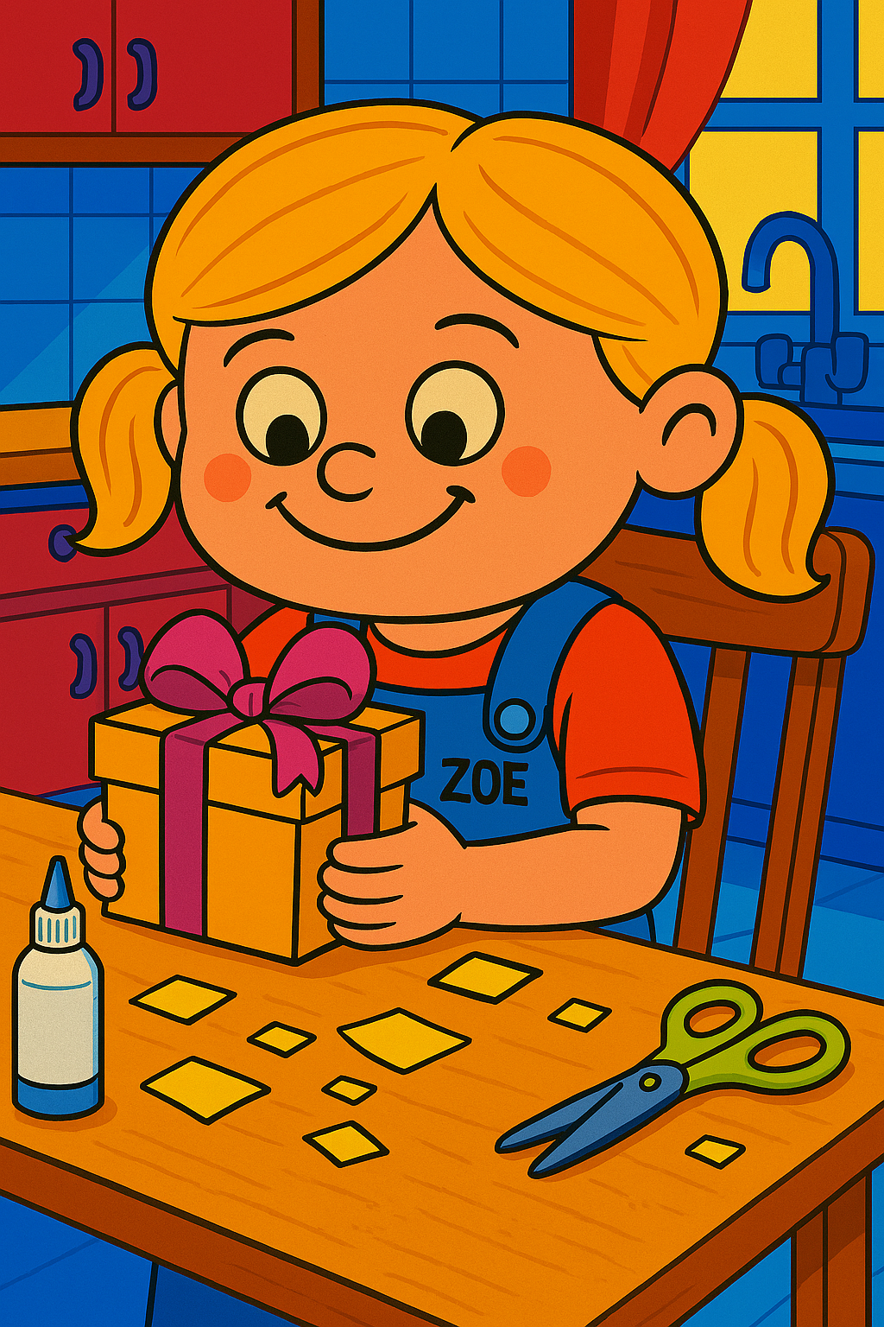
Zoe lived with her father. Her mother had moved to America many years before. Zoe did miss her mum, but living with Dad was OK. She was 6.
It was Christmas Eve and Zoe had spent the whole afternoon at the kitchen table with the scissors. They were special craft scissors for children and designed to be safe. Dad could hear lots of cutting sounds as he sat in the living room watching television.
But when dad eventually went to the kitchen to investigate, he was furious.
“What a waste of money! Why have you used that good wrapping paper? You really are silly.”
Her dad was cross. They didn’t have much money, and the last thing Zoe’s father wanted was for her to waste their most expensive wrapping paper on her game. She had cut the shiny gold wrapping paper up and now it was no good for anything. He grew even more upset when, after sending her to her room for cutting the paper up, he saw her pasting it onto an old box.
“What are you doing that for?” he protested. “We could have used that paper for your granny’s present.”
A little later, the same shiny box with its gold-wrapping now firmly stuck to the box appeared under the Christmas tree. But when dad looked at the tag his anger soon subsided. He felt almost embarrassed when he saw the words, “too Daddy love Zoe” written on it.
That night Zoe went to bed early – as every six year old does on Christmas Eve – hoping that the morning might come more quickly. Eventually, after a very sleepless night, Zoe rushed into her dad’s bedroom at 6 a.m. She shook him until he eventually woke up. He was still very sleepy and knew that church didn’t start for another 3 hours. He rubbed his eyes until the sleepiness began to go. Then he stumbled into the bathroom to throw cold water over his face, and made his way downstairs. He was feeling a bit grumpy about being up so early, but he smiled as Zoe opened her presents. The Barbie doll and the lovely outfits, the new slippers, pink pyjamas, lots of books that she has ask for, new trainers with lights on… eventually all her presents were opened and all that remained under the tree was the golden box.
Zoe went to collect it and handed it to Dad. He decided that he didn’t mind being woken up at 6 a.m. for it must be a wonderful present to be put inside such a shiny box. He took his time opening the lid and then he gazed inside.
But he became quite angry as he looked into the box. He looked at his little girl and spoke to her sharply. “Young lady, don’t you know that when you give a present to someone there’s supposed to be something inside?” The Shiny Golden Box looked empty.
The little girl looked up with tears in his eyes and said: “Oh, Daddy, it’s not empty. I sat in my bed all yesterday afternoon and I blew kisses into it until it was full. And then I put the lid on so none could escape. I’ve made you a box full of love.”
Dad said nothing, but tears ran down his cheeks as he hugged his little girl tight.
And that’s what happened all those thousands of years ago. God the father gave us a shiny box full of love. His name was Jesus. God’s gift of love to us. A gift that shines in the darkness and the darkness will never overpower it.

